# POWER SKILL

* Para verbal tone is important
* In mails for salutation for team(plural), we should write Dear Team or Dear All or Dear colleagues

For senior officials, we should keep hello

For batchmates, hi

* Opening statement: hope this mail finds you well
* Bcc should not be used in Capgemini emails

**Session 3**

* A and an are used in general, Single countable noun, introduce something for the first time, speaking about someone’s job, want to say 1 with big numbers, how many times?
* The used for specific, when we mention something for 2nd time, with superlatives, with groups of society, when there is one of something, with plural countries, with instruments, with mornings afternoon evening

**Session 4**

* **Email writing**
* Urgent – immediate action needed so to communicate we don’t use email
* Subject line
* Salutation – acknowledgement / it shows respect, courtesy
* Hello (first name);
* DEAR ALL – in email we are not supposed to use as it is in capitals – it is like yelling or offensive
* Opening statement – opening statement should not be written as a part of the body
* Body of the mail – the main information
* Comes after opening statement

# 

* Closing statement
* Signature
* **Presentation**

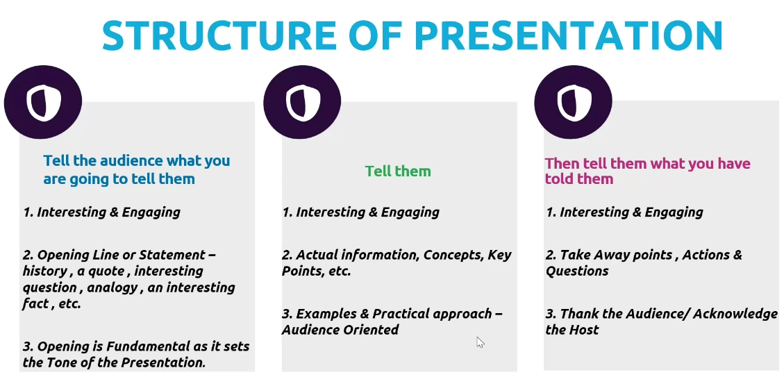

* The delivery – rate of speech, tone & pitch

* Listening and comprehension
* Decide to be a good listener
* Welcome the caller